A TRUE STORY OF A LONG GRASS MARTYR: Bob Bunduwabi 1931 - 1997
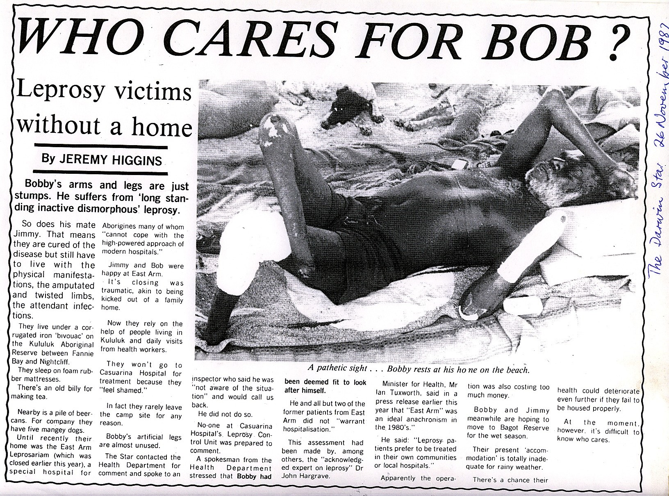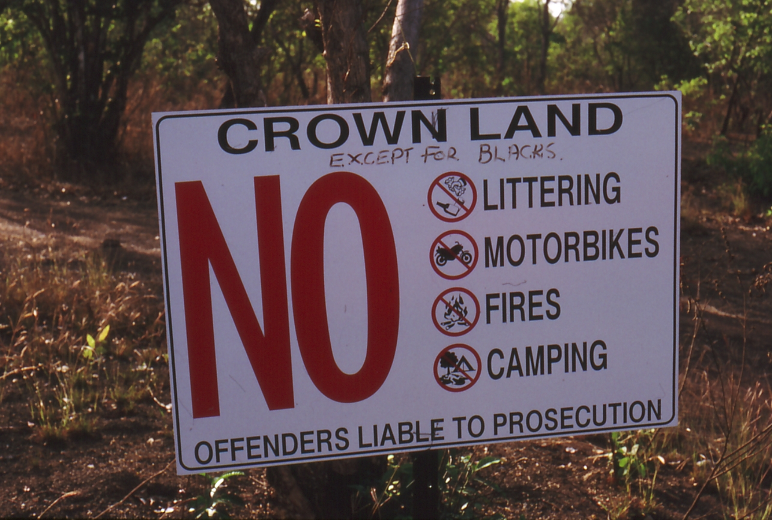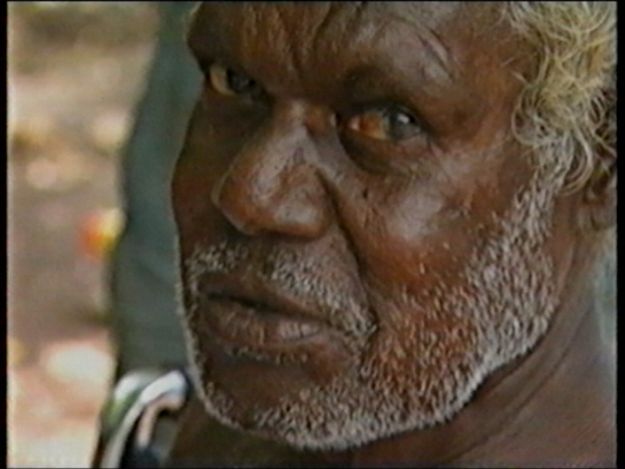
As a young man Bob Bunduwabi had been taken to the East Arm Hospital. After the hospital was closed in 1982 Bob camped in the bush around Darwin. Before long, the NT Government or the City Council would order Gojok (his skin name) to move on.
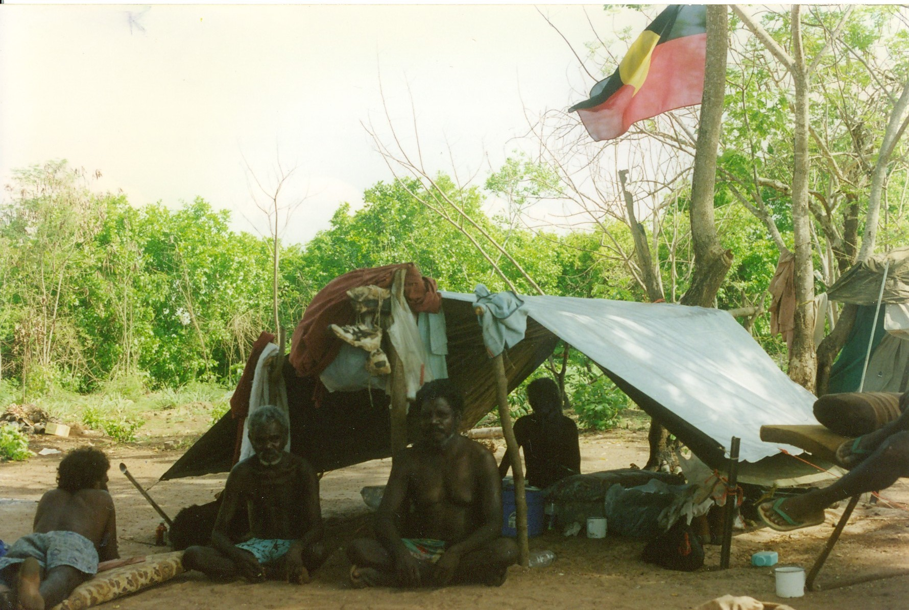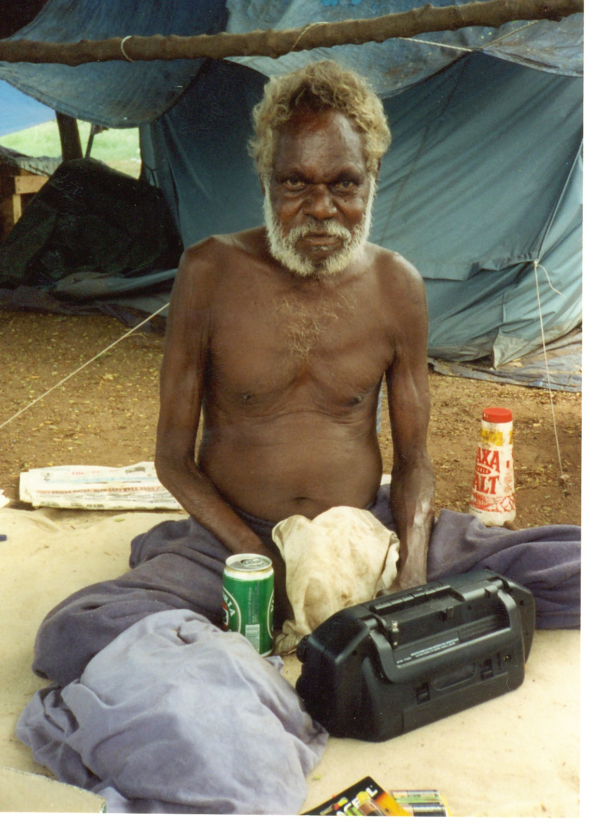
After he was evicted from Lee Point in July, 1996, he went to Fish Camp to stay with Burarra people from Arnhem Land. The camp was beside Ludmilla Creek.
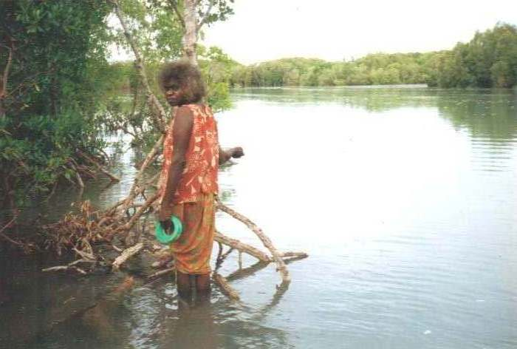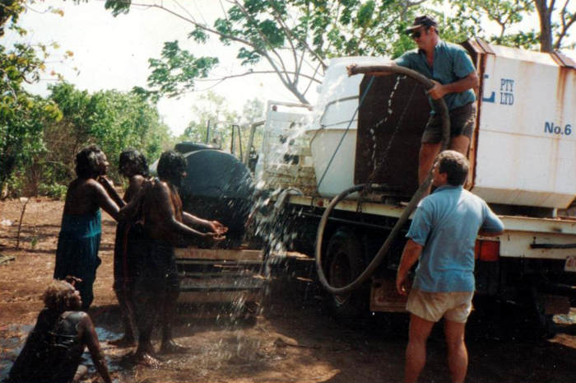
At high tide Dulcie caught fish in the creek. Their only fresh water came in a truck.
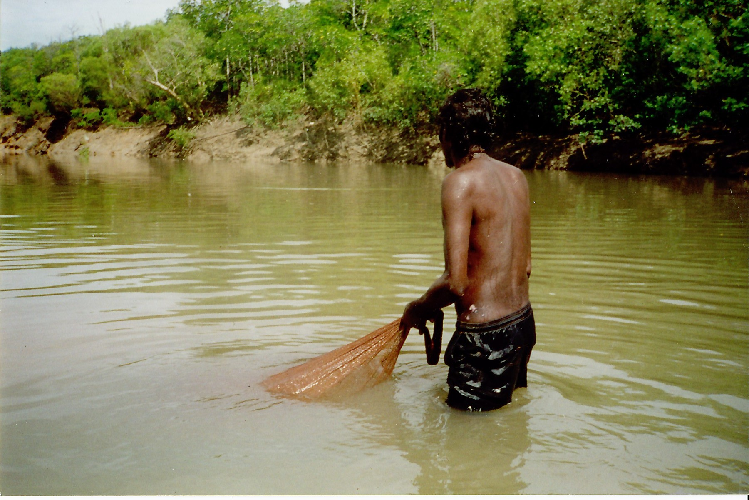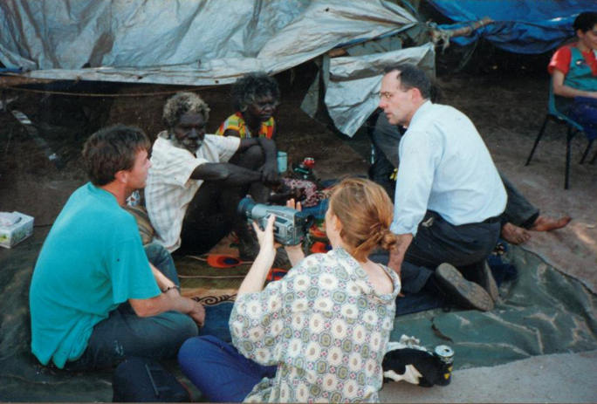
Len used his cast net in the creek. Politicians came to visit, but nothing changed.

